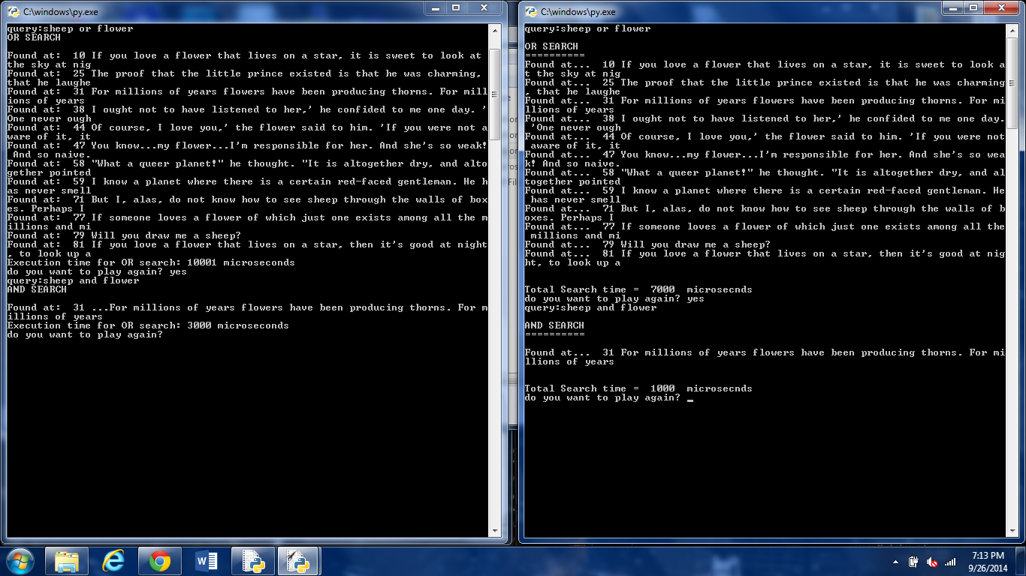

The search on the left is the part 1 for homework 2. This splits the data_list into quotes and then the quotes are split into words. It then searches through those words to see if the query is in that list of words. It was slower than part 2 because it went through the entire data list.

The search on the right is the part 2 for homework 2. This search used a dictionary to store the words in the data list. First it went through and found each slot that the word was found and stored that into a list. The word was then stored into the dictionary as a key and the list of slots where it was found in the data_list was the key. This search was faster because I used an if statement that said if the query was in the dictionary then it would use the values in the dictionary to print out those corresponding elements in the data_list. This reduced the search because it didn’t have to search through the entire data list.